**Tutorial – 1**

**1. Write a program to print “Hello World”.**

using System;

namespace Tutorial1{

    class Q1{

        static void Main(String[] args){

            Console.WriteLine("Hello World");

            Console.ReadLine();

        }

    }

}

**Output:**

**2 : Design your profile page as given below.**

$$$$$$$$$$$$$$$$$$$$$$$$$$$$$$$$$$$$$$$$$$$$$$

Name: Ramesh Tamkuity

DOB: 15/10/1991

Address: 4, xyx society,

                 Kalawad Road

City: Rajkot

Pincode: 360 001

State: Gujarat

Country: India

Email: abc@ymail.com

$$$$$$$$$$$$$$$$$$$$$$$$$$$$$$$$$$$$$$$$$$$$$$

using System;

namespace Tutorial1{

    class Q1{

        static void border(){

            for(int i = 0; i < 20; i++)

                Console.Write("$ ");

        }

         static void Main(String[] args){

            border();

            string name, dob, address, city, pincode, state, country, email;

            name = "Sanjay Kumar Sah";

            dob = "28/06/2000";

            address = "105 - A, Boys Hostel\n\t\tRK University";

            city = "Rajkot";

            pincode = "360020";

            state ="Gujrat";

            country = "India";

            email = "ssah007@rku.ac.in";

            Console.WriteLine("\n\nName: {0}",name);

            Console.WriteLine("DOB: {0}\nAddress: {1}\nCity: {2}\nPincode: {3}\nState: {4}\nCountry: {5}\nEmail: {6}\n\n", dob, address, city, pincode,state,country,email);

            border();

        }

    }

}

**Output:**

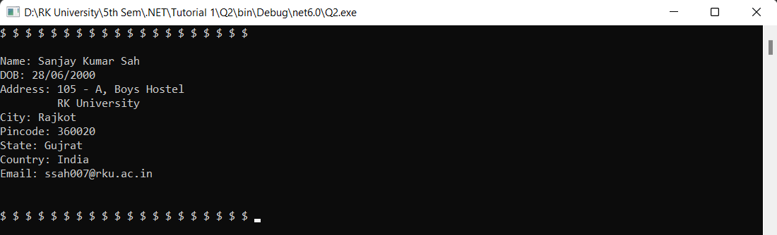

**3 : Find out whether the given number is odd or even.**

//3 : Find out whether the given number is odd or even.

namespace HelloWorld

{

    class Program

    {

        static void Main(string[] args)

        {

            Console.Write("Enter a number: ");

            int n = Convert.ToInt32(Console.ReadLine());

            if(n%2==0)

                Console.Write("{0} is even number",n);

            else

                Console.Write("{0} is odd number",n);

        }

    }

}

**Output:**

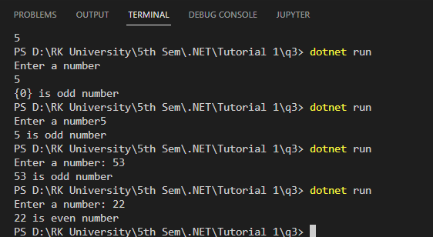

**4 : Rearrange the given code to correct the program. The resultant program will be to input a number and print whether the given number is odd or even.**

namespace ConsoleApplication1

{

    {

        static void Main(string[] args)

        {

            int x;

            Console.WriteLine("Enter Number : ");

            x = Convert.ToInt32(str);

            Console.WriteLine("Number is Even");

            else

            Console.Read();

                           string str = Console.ReadLine();

             if (x % 2 == 0)

            Console.WriteLine("Number is Odd");

        }

    }

}

class Program

using System;

// 4 : Rearrange the given code to correct the program. The resultant program will be to input a number and print whether the given number is odd or even.

using System;

namespace ConsoleApplication1

{

    class Program

    {

        static void Main(string[] args)

        {

            int x;

            Console.WriteLine("Enter Number : ");

            string str = Console.ReadLine();

            x = Convert.ToInt32(str);

            if (x % 2 == 0)

                Console.WriteLine("Number is Even");

            else

                Console.WriteLine("Number is Odd");

            Console.Read();

        }

    }

}

**Output:**

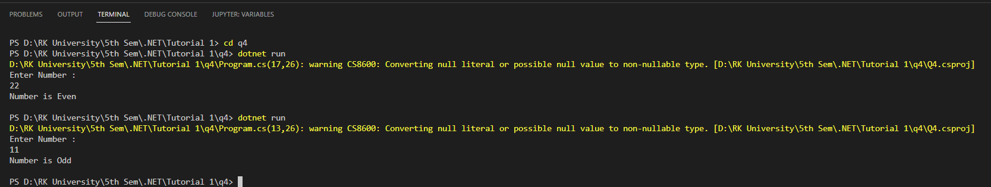

**5 : Write output of the program. Also write comment for each line for the following code.**

using System;

namespace ConsoleApplication1

{

    class Program

    {

        static void Main(string[] args)

        {

            int n,fact=1;

            Console.WriteLine("Enter Number : ");

            string str = Console.ReadLine();

            n = Convert.ToInt32(str);

            for (int i = 1; i <= n; i++)

            {

                fact = fact * i;

            }

            Console.WriteLine("Factorial : {0}",fact);

            Console.Read();

        }

    }

}

// 5 : Write output of the program. Also write comment for each line for the following code.

using System;

namespace ConsoleApplication1

{

    class Program

    {

        static void Main(string[] args)

        {

            int n,fact=1;

            Console.WriteLine("Enter Number : ");

            string str = Console.ReadLine();

            n = Convert.ToInt32(str);

            for (int i = 1; i <= n; i++){

                fact = fact * i;

            }

            Console.WriteLine("Factorial : {0}",fact);

           Console.Read();

        }

    }

}

Output:

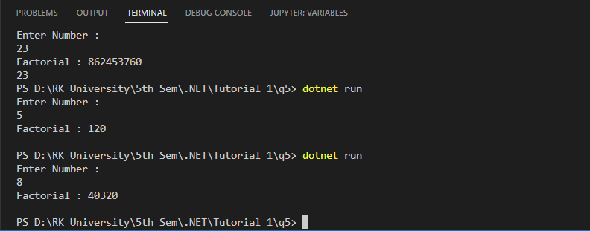

**6 : Write missing statement to get the desired output.**

using System;

namespace ConsoleApplication1

{

    class Program

    {

        static void Main(string[] args)

        {

            int a,b,c,result;

            Console.Write("Enter Number   1: ");

   //Missing statement

            a = Convert.ToInt32(str);

            Console.Write("Enter Number  2 : ");

   //Missing statement

            b = Convert.ToInt32(str);

            Console.Write("Enter Number   3 : ");

            str = Console.ReadLine();

   //Missing statement

            result = Sum(a, b, c);

   //Missing statement

            Console.Read();

        }

        static int Sum(int x, int y, int z)

        {

            int res;

            res = x+y+z;

            return res;

        }

    }

}

    Output:

    Enter Number 1 : 10

    Enter Number 2 : 20

    Enter Number 3 : 30

    Sum : 60

// 6 : Write missing statement to get the desired output.

using System;

namespace ConsoleApplication1

{

    class Program

    {

        static void Main(string[] args)

        {

            int a,b,c,result;

            Console.Write("Enter Number   1: ");

   //Missing statement

            string str = Console.ReadLine();

            a = Convert.ToInt32(str);

            Console.Write("Enter Number  2 : ");

   //Missing statement

            str = Console.ReadLine();

            b = Convert.ToInt32(str);

            Console.Write("Enter Number   3 : ");

            str = Console.ReadLine();

   //Missing statement

            c = Convert.ToInt32(str);

            result = Sum(a, b, c);

            Console.WriteLine("Sum {0}", result);

   //Missing statement

            Console.Read();

        }

        static int Sum(int x, int y, int z)

        {

            int res;

            res = x+y+z;

            return res;

        }

    }

}

**7 : Predict and write the output of the given code.**

     using System;  
namespace While_Loop  
{  
  class Program  
   {  
     static void Main(string[] args)  
      {  
        int num1,res, i;  
   
        Console.WriteLine("Enter a number");  
        num1 = Convert.ToInt32(Console.ReadLine());

        i = 1; //Initialization

        //Check whether condition matches or not  
        while (i <= 10)  
         {  
           res = num1 * i;  
           Console.WriteLine("{0} x {1} = {2}", num1, i, res);

                i++; //Increment by one  
         }  
        Console.ReadLine();             
      }  
   }  
}

// 7 : Predict and write the output of the given code.

using System;

namespace While_Loop

{

    class Program

    {

        static void Main(string[] args)

        {

            int num1, res, i;

            Console.WriteLine("Enter a number");

            num1 = Convert.ToInt32(Console.ReadLine());

            i = 1; //Initialization

            //Check whether condition matches or not

            while (i <= 10)

            {

                res = num1 * i;

                Console.WriteLine("{0} x {1} = {2}", num1, i, res);

                i++; //Increment by one

            }

            Console.ReadLine();

        }

    }

}

8 Write a program to convert given name in upper characters.  
INPUT : John F Kennedy  
OUTPUT: JOHN F KENNEDY

// 8 Write a program to convert given name in upper characters.

namespace HelloWorld

{

    class Program

    {

        static void Main(string[] args)

        {

            string str = "Sanjay Kumar Sah";

            Console.WriteLine("{0}", str.ToUpper());

        }

    }

}



9 Write a Program to convert given name in toggle case.  
INPUT : JoHn F kEnNedy  
OUTPUT: jOhN f KeNneDY

namespace Q9

{

    class Program

    {

        static void Main(string[] args)

        {

            String str = Console.ReadLine();

            Console.WriteLine("{0}", toggle(str));

        }

        static string toggle(string str){

            string s = "";

            foreach(Char c in str){

                if(Char.IsLower(c))

                    // Console.WriteLine(c);

                    s += Char.ToUpper(c);

                else if(Char.IsUpper(c))

                    s += Char.ToLower(c);

                else

                    s += c;

            }

            return s;

        }

    }

}

Output:

10. Write a Program which accepts mobile no as a string from the user and converts the last 5 digits into X.  
INPUT : 1234567890  
OUTPUT: 12345XXXXX

namespace Q10

{

    class Program

    {

        static void Main(string[] args)

        {

            string num = Console.ReadLine();

            Console.WriteLine("{0}", change(num));

        }

        static string change(string n){

            char [] ch = n.ToCharArray();

            for(int i = ch.Length - 5; i < ch.Length; i++){

                ch[i] = 'X';

            }

            return new String(ch);

        }

    }

}



11. Write a Program which accepts name and gender from the user. Here, gender may have only 1 character, M or F.  
Based on the gender prefix the name Mr. & Ms.  
NAME : Hillary Clinton  
GENDER : F

// 11  Write a Program which accepts name and gender from the user. Here, gender may have only 1 character, M or F.

// Based on the gender prefix the name Mr. & Ms.

// NAME : Hillary Clinton

// GENDER : F

namespace Q11

{

    class Program

    {

        static void Main(string[] args)

        {

            string name = Console.ReadLine();

            char gender =  Char.ToUpper(Console.ReadLine()[0]);

            if(gender == 'M')

                Console.WriteLine("Mr. {0}", name);

            else if(gender == 'F')

                Console.WriteLine("Ms. {0}", name);

        }

    }

}

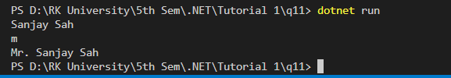

12. Write a Program to prints the following series  
0 1 1 2 3 5 8 13 21 34 55

namespace Q12

{

    class Program

    {

        static void Main(string[] args)

        {

            int n = Convert.ToInt32(Console.ReadLine());

            int i = 1;

            while(fib(i) <= n){

                Console.Write("{0} ", fib(i));

                i++;

            }

        }

        static int fib(int n){

            if(n <=1){

                return n;

            }

            return fib(n-1)+fib(n-2);

        }

    }

}

Output:

13. Write a Program which accepts no from the user and print the same in words.  
INPUT : 98732  
OUTPUT: Nine Eight Seven Three Two

namespace Q13

{

    class Program

    {

        static void Main(string[] args)

        {

            string[] units = {"", "One", "Two", "Three", "Four", "Five", "Six", "Seven", "Eight", "Nine"};

            Console.Write("Input: ");

            string n = Console.ReadLine();

            for(int i = 0; i < n.Length; i++){

                Console.Write("{0} ", units[n[i]-'0']);

            }

        }

    }

}

15.  Write a Program to check whether the given no is Armstrong no or not.

// 15.  Write a Program to check whether the given no is Armstrong no or not.

namespace Q14

{

    class Program

    {

        static void Main(string[] args)

        {

            Console.Write("Input: ");

            int n = Convert.ToInt32(Console.ReadLine());

            int temp = n;

            double newNumber = 0;

            double pow = Math.Floor(Math.Log10(temp) + 1);

            while(temp>0){

                double rem = temp % 10;

                rem = Math.Pow(rem, pow);

                newNumber += rem;

                temp /= 10;

            }

                Console.WriteLine("{0} is Armstrong number", newNumber);

            if(n == newNumber)

                Console.WriteLine("{0} is Armstrong number", n);

            else

                Console.WriteLine("{0} is not Armstrong number", n);

        }

    }

}

Output:

